Spring 2020
Business 343 - Sec 1 - Principles of Insurance
Wednesday 16:00 – 18:30
CCC Room 214

Marcia Tepp
E-mail: mtepp@uwsp.edu Campus Office : CPS 338B
Office Hours: Wednesdays 14:30 – 15:30
& by appointment
Contact me via home phone 715.345.0180 or Cell 715.581.8683

SBE Mission: | The UW-Stevens Point School of Business and Economics creates career ready graduates and leaders through applied learning. We serve the businesses, economy, and people of the greater Central Wisconsin region. We specialize in preparing students for success by providing professional development experiences, access to employers, and in-demand skills.  The SBE achieves its mission by valuing:  - Talent development  - Lifelong learning  - Career preparation  - On the job experiences  - Community outreach  - Regional partnerships  - Continuous improvement
Accreditation Commitment: | SBE is accredited by the Association to Advance Collegiate Schools of Business (AACSB), a designation earned by only 5 percent of world business schools. Accreditation instills a culture of continuously improving our programs through connections with local business leaders, alumni and the community.

Required text:
Principles of Risk Management and Insurance, 13th Edition, George E. Rejda, Harper Collins Publishers. Additional
Bring your text book to each and every class; you will often use it in class.

Course objective:
The course will introduce the basic principles that underlie the field of insurance. Several insurance policies will be used to present concepts and policy provisions common to the insurance mechanism. The risk management approach will be stressed in the use of personal and business insurance. During the course, you will also be exposed to the various career opportunities in the insurance industry.

At the end of the course you will:
- Be familiar with various types of insurance.
- Understand how insurance can positively impact your personal life.
- Understand how insurance enables businesses to operate in today’s society.
- Understand the process of risk management and know how to apply it to your decision making.
- Expand your knowledge of a current situation impacting society and insurance through completion and presentation of a research paper.
- Improve presentation skills by presenting ideas in coherent and convincing manner.

Class meetings and attendance:
Attendance will benefit you and your grade. You are encouraged to be an active participant in class. If you make the choice not to attend class, be aware that there will be no opportunity to make-up in class activities. You will be able to earn 20 points during each class session. I am not able to re-teach the material to you, in the event that you are absent, but you can ask a classmate to share notes.

For the best learning experience, it is expected that you read related materials in the text prior to class and be prepared to answer questions in class. We will operate on that premise. See the detailed schedule for the chapters and the order we will be covering the material. We may deviate from the schedule depending on the guest speakers and tours that are involved with the class.

Concepts and policies will be presented by lecture, discussion and assigned activities. There will be activities assigned during the week and during class. Participation will be graded. Be prepared to ask and answer questions in class. I intend to cover the most important concepts from the textbook in class. However, you are still responsible for developing an understanding of other concepts and terms not covered. If you have questions about something not covered in class, please ask.

You will be involved in individual and team activities in class. When operating in teams the team will receive one grade for a given team activity and each member in the team will receive the same grade. If you want to receive a high team activity grade be active in your team and perform.

During class we may access the Internet, so cell phones and other electronic devices that access the Internet are allowed in class, when we will be utilizing them. Research supports that having visual access to a cell phone diminishes our ability to learn. Checking social media, texts, emails, and messages is unprofessional and disrespectful to our class community. Please turn off your phone during class; I will do so as well. If I notice that you are using your phone during class, I may ask you to share what you are researching or ask you to put it away. Thank you for following these guidelines as they help create a positive learning community.

We may have tours of local Stevens Point businesses as part of the class. It is your responsibility to get to the business on time on the assigned date. Missing a tour will be treated the same as missing a class and activities assigned may not be made up.

We may have guest speakers during the semester. It is expected that they be treated as guests and thanked for spending time with the class. They will expect questions during their presentation, so be prepared to ask questions.

Review the UWSP policy on attendance at: http://www.uwsp.edu/regrec/Pages/Attendance-Policy.aspx

Insurance Current Events
Each week up to four students will have the opportunity to present information on a current event they found that is impacting the insurance industry. A current event is one that has been in the press within the past month. A notice that an agent or insured has been charged or convicted of fraud is not considered to be a current event. It must be an event that impacts the industry. A repeat of a previous current event given by another student will not be counted as a current event presentation. Potential sources of information are the internet, TV and newspapers. When you present your current event be sure to include your source and indicate how it impacts the insurance industry.
Each student will have the opportunity to present three current events during the semester, limited to one per student per class session. Each presentation is worth 30 points. A total of 90 points can be earned.
Prior to class you should send an email to me letting me know that you have a current event to present as the number of current event presentations are limited to four per class. You should consider presenting your current events early in the semester as often students are unable to present due to the limit of four per class.

Exams and Assignments:
There will be six exams and six assignments throughout the semester.

All exams, other than the take home exam, will be 30 minutes long. The exams will largely be objective, short answer and situational problems. At a minimum you will be able to use your in-class notes for exams. In addition, some exams may include use of the text book. Remember that all exams will be 30 minutes long, so don’t rely on the fact that you can use your book/notes during the exam to not to prepare for an exam. Some exams maybe take home and assigned electronically, some will be given in class.

All material in the text book, additional reading material, material presented in class and business tours may be used in exams. Exams will be given upon completion of the material. Make up exams will only be given under special circumstances with prior approval.

Assignments may be due before or after we cover material in-class.

Research paper
The assigned research paper will be due April 1. We will use the papers as a basis for discussion to further cover and understand important aspects of the subject material. Keep a copy of your handed-in paper for use in group presentation and discussion. Be prepared to present and defend your conclusions/positions. There will be a group presentation of papers on May 6th. Material presented by the groups may be included in the final exam

Written Assignments Standards
All written assignments are to follow the American Psychological Association (APA) style guidelines for documentation, grammar, spelling, and punctuation. Points will be deducted for those deviating from APA style. Use the Publication manual of The American Psychological Association (6th ed.) for all writing projects you do for this class. The guidelines are included in Canvas, under References. Also included in References is information on formatting references in Word.

Canvas:
Canvas will be utilized for the class. Assignments will be posted in Canvas. It will be your responsibility to check it often for information. Links for insurance industry related websites will be posted and maybe helpful in research. PowerPoints for each chapter will be posted.

Final:
The final exam will be comprehensive, covering all material form the semester. The final exam is scheduled for Friday May 15, 10:15 – 12:15. It will not be given early nor can the time for the exam be changed.

Student evaluation:
Points will be assigned for each activity group.
Exams 600 points
Assignments 300 points
In-Class Work 300 points
Current Events 90 points
Research Paper 300 points
Final Exam 200 points
Total 1,790 points

It is expected that students will be prepared to discuss or explain incidents, cases and problems. This follows the education methods used in the development of business employees and we will use this approach.
Students who wish to receive a particular grade must earn the following points:

 | From | TO
A | 1790 | 1718
A- | 1717 | 1647
B+ | 1646 | 1575
B | 1574 | 1503
B- | 1502 | 1432
C+ | 1431 | 1360
C | 1359 | 1289
C- | 1288 | 1217
D+ | 1216 | 1146
D | 1145 | 1074
D- | 1073 | 1002
F | 1001 | 0

Contacting Me
Call me at any time (715.345.0180). Leave a voicemail if I do not answer. I will respond to messages that are left. Feel free to also email me. Remember some faculty receive as many as 100 emails per day. Yours should be clear, concise, and professional so that your issues can be responded to effectively. Include the entire thread of an ongoing email conversation so that I can recall the history of your issue without searching for other emails you have sent. Sign off with your first and last name. I will not open attachments without a subject.

Office Hours
My office is located in CPS 338B. I am available without an appointment on Wednesdays 2:30-3:30. Individual meetings can be arranged through an email request, phone call, or conversation directly before or after class.

Exams and Assignments that are to be submitted into Canvas are due at the date and time shown. Canvas will have a hard close at the date and time shown, normally the Tuesday before class at 11:59 AM. No submission will be accepted after the date and time shown, so plan accordingly.

Help:
In addition to Wednesday office hours, I will be available by special appointment. My schedule is flexible. Feel free to call me at my home phone number or contact me via e-mail and schedule time. Do not wait until the last minute to e-mail me questions before an exam.

Academic Misconduct
This course is part of the UW-Stevens Point academic community, an academic community that is bound together by the traditions and practice of scholarship. Honest intellectual work – on examinations and on written assignments is essential to the success of this community of scholars. Using classmates’ responses to answer exam questions or disguising words written by others as your own undermines the trust and respect on which our course depends.

The work in this course is challenging and will demand a good deal of each of you. I have every confidence that each of you can succeed. Doing your own work will enhance your sense of accomplishment when the semester comes to a close.

Additionally, the classroom environment is a unique opportunity for students to share ideas, opinions, discuss classroom and course content. As each student is entitled to contribute in class, specific expectations are necessary to ensure a thriving classroom environment. Expectations include: arriving to class on time, being prepared for class, no electronic devices, unless authorized to do so, any loud shouting, excessive side conversations, arriving to class under the influence of any alcohol or drugs, profane language, and verbal or physical threats, intimidation of any kind, or any other behavior that may be disruptive to the professor or other students. If any of this behavior is exhibited, you may be asked to leave the class for the day. Any continued disruptive behavior may result in a referral to the Dean of Students Office.

Academic Honesty
Academic Integrity is an expectation of each UW-Stevens Point student. Campus community members are responsible for fostering and upholding an environment in which student learning is fair, just, and honest. Through your studies as a student, it is essential to exhibit the highest level of personal honesty and respect for the intellectual property of others. Academic misconduct is unacceptable. It compromises and disrespects the integrity of our university and those who study here. To maintain academic integrity, a student must only claim work which is the authentic work solely of their own, providing correct citations and credit to others as needed. Cheating, fabrication, plagiarism, unauthorized collaboration, and/or helping others commit these acts are examples of academic misconduct, which can result in disciplinary action. Failure to understand what constitutes academic misconduct does not exempt responsibility from engaging in it. No plagiarism or cheating will be tolerated and can result in an F grade for the class. All written work submitted to the drop box in D2L will be evaluated by turnitin.com.
Students suspected of academic misconduct will be asked to meet with the instructor to discuss the concerns. If academic misconduct is evident, procedures for determining disciplinary sanctions will be followed as outlined in the University System Administrative Code, Chapter 14.

Student Rights and Responsibilities/Academic Misconduct
Please be sure to review the information on student rights at the following: http://www.uwsp.edu/acadaff/Pages/gradeReview.aspx

ADA Statement
UW-Stevens Point will modify academic program requirements as necessary to ensure that they do not discriminate against qualified applicants or students with disabilities. The modifications should not affect the substance of educational programs or compromise academic standards; nor should they intrude upon academic freedom. Examinations or other procedures used for evaluating students' academic achievements may be adapted. The results of such evaluation must demonstrate the student's achievement in the academic activity, rather than describe his/her disability. If modifications are required due to a disability, please inform the instructor and contact the Disability and Assistive Technology Center to complete an Accommodations Request form. Phone: 346-3365 or Room 609 Albertson Hall. You must have a completed approved form to qualify for an accommodation. See the information on ADA at:
http://www.uwsp.edu/disability/

Emergency Response
Be familiar with what you should do in the event of an emergency.
Medical Emergency – In the event of a medical emergency call 9-1-1 or use the Emergency Phone located next to room 231. Offer assistance if trained and willing to do so. Guide emergency responders to victim.
Tornado Warning – In the event of a tornado warning proceed to an interior room without window exposure.
Fire Alarm – In the event of a fire alarm evacuate the building in a calm manner. Meet across Fourth Ave, in front of the HEC building.
Active Shooter/Code React – Run/Escape, Hide, Fight. If trapped, hide, lock doors, turn off lights, spread out and remain quiet. Call 9-1-1 when it is safe to do so. Follow instructions of emergency responders.

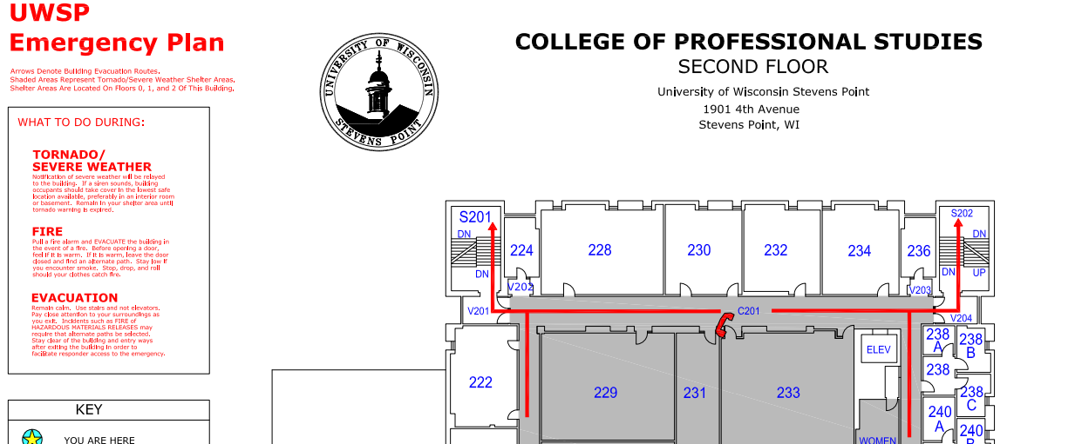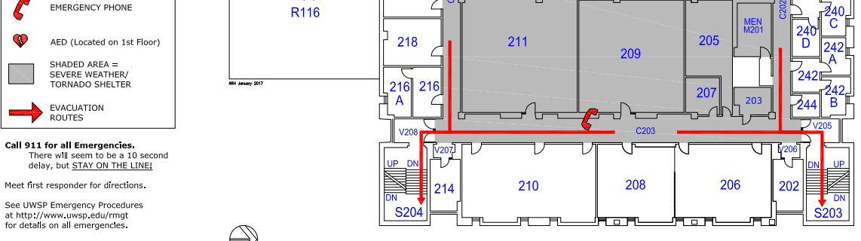

January 22 & Jan 29 Basics of Risk and Insurance Chapters 1 & 2 Exam
February 5 Risk Management Chapter 3 Assignment
February 12 Legal Principles Chapters 9 & 10 Assignment
February 19 Liability Risk Chapter 19 Assignment
February 29 Auto Insurance Chapters 20 & 21 Exam
March 4 Homeowners Insurance Chapters 22 & 23 Exam
March 11 Commercial Insurance Chapters 25, 26, 27
March 18 Spring Break
March 25 Commercial Insurance Chapters 25, 26, 27 Take Home Exam
April 1 Paper Due
April 1 Social Insurance Chapter 18 Exam
April 8 Annuities & IRAs Chapter 14 Assignment
April 15 Health Insurance Chapter 15 Assignment
April 22 Employee Benefits Chapters 16 & 17 Assignment
April 29 Life Insurance Chapters 11 & 12 Exam
May 6 Presentation of papers
May 15 Final Exam 10:15 – 12:15

Schedule is subject to change based on progress in class covering the material. Exams will be given the week following completion of material.

